Plant Measurement Practice: Milkweeds

Milkweed plants are known for their production of toxic cardenolides and milky white latex, among other defenses, and they are the primary food source for monarch caterpillars. Cardenolides are steroids that affect heart function by disrupting sodium potassium pumps. One kind of cardenolide is used in modern medicine to treat people with heart failure. We’ll be using milkweed plants to practice measuring plants.

A. Total Number of Nodes.

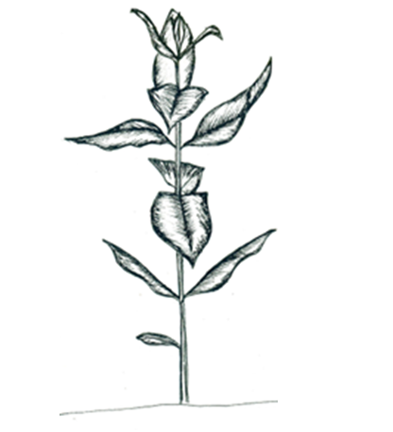
1. A node is the place on a plant where the leaves attach to a stem. Even after the leaves fall off, the nodes remain as bumps on the stem. In milkweed plants, leaves are opposite, so nodes are typically found across from each other, in pairs, going up the stem.
Do not count the nodes or leaves at the top of the plant, or on a branch, if they are less than 1 mm from the node below.
Illustration by Jacqueline Nuzzo
Count this as 2 nodes, even though there are no leaves.
Count this as 2 nodes, even though there is just one leaf.

2. Be sure you count each node individually, not each pair of nodes.

3. Starting at the base of the plant where it meets the soil, count each individual node, regardless of whether or not there is a leaf attached.

4. If the plant has branches, count the nodes systematically on each of the branches and the main stem.

5. If two pairs of nodes are less than 1 mm apart, count the lower pair of nodes but NOT the higher pair of nodes.

6. Record the total number of nodes on the whole plant.

B. Number of Leaves.

1. Starting at the base of the plant where it meets the soil, count each leaf. Even if a leaf is shriveled/brown but remains attached to the plant when you touch it lightly, then count it.

2. Be sure to count each individual leaf, not each pair of leaves.

3. If the plant has branches, count the leaves systematically on each of the branches and the main stem.

4. If two pairs of nodes are less than 1 mm apart, count the leaf/leaves on the lower pair of nodes but NOT the ones on the higher pair of nodes.

C. Stem Height (cm).

1. Using a meter stick, measure from the base of the plant where it meets the soil to the highest node. Record your measurement in centimeters.

2. It is important not to measure to the tip of the highest leaf; instead, only measure to the highest node. If two nodes are less than 1 mm apart, measure to the lower node- the higher node does NOT count.

D. Stem Diameter (mm).

1. Measure the diameter of the largest stem 1 cm above the soil line using one of the methods below.

a. Caliper Method: Using a pair of calipers, gently measure the diameter of the stem at the base of the plant 1 cm above the soil. For more information on using calipers, please see the following video: https://www.youtube.com/watch?v=FNdkYIVJ3Vc.

b. Alternative Tape Measure Method: Using a flexible tape measure, measure the circumference of the stem at the base of the plant 1 cm above the soil. Divide your circumference by π (3.14) to obtain the diameter.

c. Alternative String Method: Using a piece of string, wrap the string around the milkweed stem at the base of the plant 1 cm above the soil, then measure the piece of string against a ruler to determine the circumference. Divide your circumference by π (3.14) to obtain the diameter.

E. Length (cm), Width (cm), and Area of Largest Leaf (cm²).

1. Locate the largest leaf on the stem. Measure the length as the distance, in centimeters, from the tip to the place where the blade of the leaf ends and meets the petiole, or stem. Measure the width at the widest point in centimeters.

2. (OPTIONAL) To calculate the area of the largest leaf, trace the outline of the largest leaf on a piece of graph paper. If there is damage to the leaf, extrapolate to where you believe the leaf should have grown to. Do not draw the stem, or petiole, of the leaf, but end your drawing of the leaf where the blade of the leaf meets the stem. Use care because leaves are easily detached from the plant.

3. Record whether or not you needed to extrapolate the leaf area due to damage. Choose NA if you did not measure leaf area.

The following steps may be completed when you return to class.

4. Print out the “1 cm Standard Graph Paper.” Cut out an area that is 10 cm x 10 cm. Mass the 10 cm x 10 cm area.

5. Cut out the outlines of the largest leaf, and mass it.

6. Using dimensional analysis, calculate the area of the largest leaf.

Mass of 100 square cm 100 sq. cm
--------------------------- = ----------------------------
Mass of traced leaf outline Area of leaf

7. Record the area of the largest leaf.

Quick Check (circle your answers):
- A node is a bump on the stem where a leaf is/was. If a leaf has fallen off, should we count the node anyway?
Yes No

- Milkweed leaves are typically found in pairs. When you are counting nodes, each pair of nodes should be counted as __________ nodes.
Zero One Two Three
- The new leaves at the top of a milkweed plant can grow close together. You should not count any leaves whose nodes are
Touching the node below < 1 mm from the nodes below > 1 mm from the nodes below
- You should measure the height of the stem in
mm cm m
- You should measure the length and width of the largest leaf in
mm cm m

- Where should you measure the stem diameter?
1 2 3

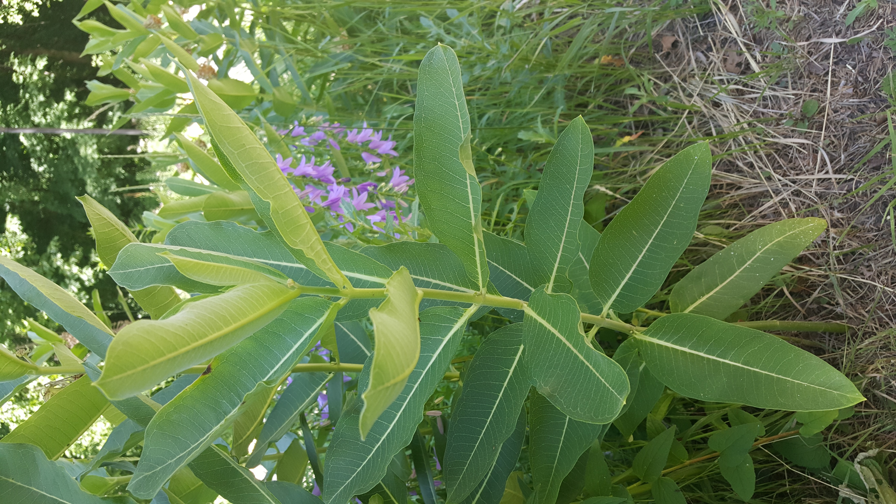
1
2
3

