**ES 237*ANGELL*SPRING 2020**

**INSTRUCTIONS FOR CLASS TODAY**

1. Complete the half-page checklist handout and confess to your group what kind of person you are.

2. In your groups write two multiple choice questions based on the reading for Monday (Boston trees vs Harvard forest trees) and email to me!

3. Beth Kallestad is writing a grant to the MPCA to plant 200 trees in Northfield, however she wants some data that I think we can help her with!

*Here is what the grant looks like….*

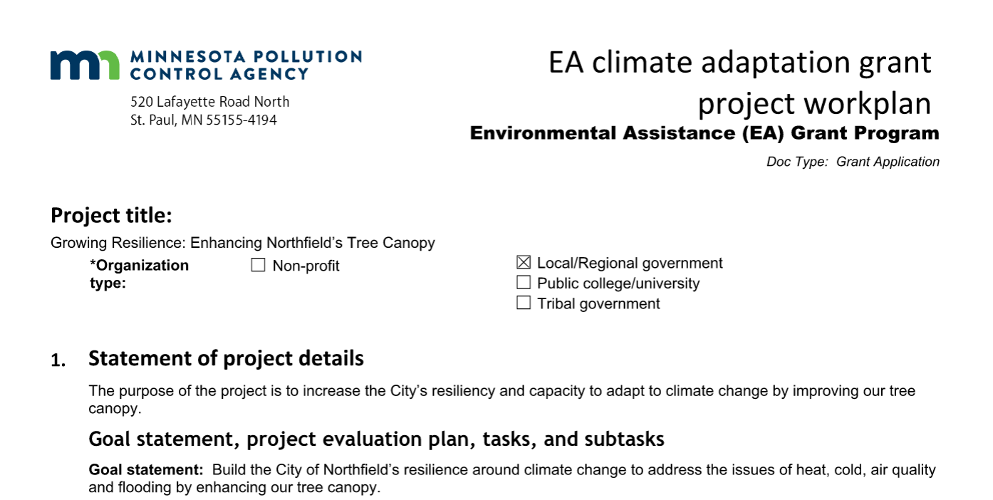

Go to the website below (and linked for class today) and enter in your assigned tree. We will do two different searches. For the first round of data assume 1 inch trees. That is the approximate planting size. Copy and past the data into the shared file and then do it all over again with a 5 inch tree size (in the Google Doc entitled “**Northfield Tree Grant Information**”).

We will not focus on property value or air quality data for this. Do enter info or the other columns (stormwater interception, kwh, therms). For energy I think it would be useful to report out both the lbs of Carbon sequestered and the lbs of Carbon avoided (what we did not emit because of the cooling due to shading and reduced needs for heating due to wind protection). These values are a little tricky to read off the graph but lets make an attempt.

<http://www.treebenefits.com/calculator/index.cfm>

4. Now we will start on our Census Block explorations! Open up Google Earth, Google maps or whatever and figure out where your census block is! Can you figure out where the divisions between the blocks are?

**Make a list** of public spaces, parks schools, churches, lower income housing, apartments complexes, major roadways or other notable town elements that you are able to identify. Feel free to make a new file in our shared folder with your group if you wish. What major features does it contain?

Think about how you would describe your assigned area to someone else. Consult with your group to **create several sentences** that describe your assigned block 3-4 qualitatively.

5. Next open up the data set in the shared folder called “**I-Tree Landscape Data**.”

Copy this and rename it to make a file for your group, but leave that file in the shared folder!

Once you open up that file you will see a ton of data from the I-Tree Landscape site pasted in by census block. For today, inspect all the data (go way to the right) and think about what columns might be interesting to explore.

Choose some variables that seem to be interesting and plot them on a column graph using the census label names I came up with (seems like words are better than Block 1, Block 2 etc…). In other words graph all the data in a single column for all the blocks in one graph.

You will see my example in the original data set. I have never used Google sheets to graph but I think it is fine for our purposes right now!

Make several graphs. Some might be less interesting than others!

**When you find a graph or two that you think are interesting, paste them along with your names into the Google Slide Show in the same folder and be prepared to share.**