Aidan P. Schoff
PHIL 257A
Professor Taliaferro
3/31/2021
A Hydroponic Ethical Dilemma
About 10,000 years ago humans began to domesticate plants and animals, allowing for the gradual transition away from the nomadic hunter-gatherer lifestyle.¹ With the new capacity to remain in particular geographic regions for an extended period of time and produce increasing amounts of food, the shift towards modern societal structure was catalyzed. Successive revolutions across the globe followed innovations that emerged from human specialization and the capacity to produce excess calories exponentially increased. Differentiation of societal class structures began to accelerate as a growing population of humans no longer needed to directly participate in agriculture in order to survive. Civilizations separately raced towards increased productive efficiency and maximization of human and natural resources. Eventually, certain human groups became productive enough to concern themselves with the resources of other human groups. Societies combined and grew larger as agricultural innovations allowed for more dense populations. Many thousands of years forward, beyond the British Agricultural Revolution and Green Revolution, we now collectively sustain billions of humans worldwide through modern agricultural practices.
The 20th century brought a rampant acceleration of productivity and interconnectedness between agricultural practices across the globe. Implementing the use of modern pesticides, high-yielding crop varieties, and extensive mechanical cultivation, we now live in the most agriculturally productive era in all of human history. The development of this age has only been possible through the technological developments of the Industrial Revolution and a staggering reliance on fossil fuels. Since the early spice trade, humans have intensively exchanged agricultural goods. Though the speed and quantity in which this practice has amassed dwarfs any former efforts. Our globalized marketplace of foodstuffs and other goods accesses any product to any nation-state if the price is right. Motivated by the continuous accumulation of capital and power, many ecological considerations have fallen to the wayside as agriculture has blossomed.
Over the same time period, irreparable damage has occurred to ecosystems at the hands of unrestricted agricultural and societal productivity. Anthropocentric climate change, fueled by the reliance on unsustainable, non-renewable energy sources, continues to threaten the ecological foundation in which modern agriculture has placed its roots. Rampant global desertification and drought, shortening growing seasons, changing climatic zones, and increasing threats of pests and disease all demonstrate a bleak trend as to the impacts of centuries worth of lacking ecological stewardship. This changing environment has already begun to leave populations at risk of starvation and emigration from previously fertile lands. By 2050, it is predicted that we will need to collectively double our current crop production in order to feed an additional 2 billion global citizens.² Understanding the shortcomings of unsustainable agricultural practices in conjunction with impending global food and water shortages, new practices are on the rise. Primarily concerned with meeting biological needs and sustaining humanity as we know it, new growth technologies are gaining popularity. In specific, hydroponic growth systems are an important contender for feeding the future.
To provide a brief overview, hydroponics is a soilless method of plant cultivation that features a nutrient-rich solution that contacts plant roots in a variety of different ways. Most often, these systems are operated indoors either in a greenhouse or brick-and-mortar building with artificial light. This style of cultivation can also be referred to as Controlled Environment Agriculture (CEA) as it is not subjected to the elements and avoids many traditional issues, like pests and disease. Additionally, CEA is incredibly water-efficient, using up to 6 times less water than traditional farming methods -- presenting a very viable future option.
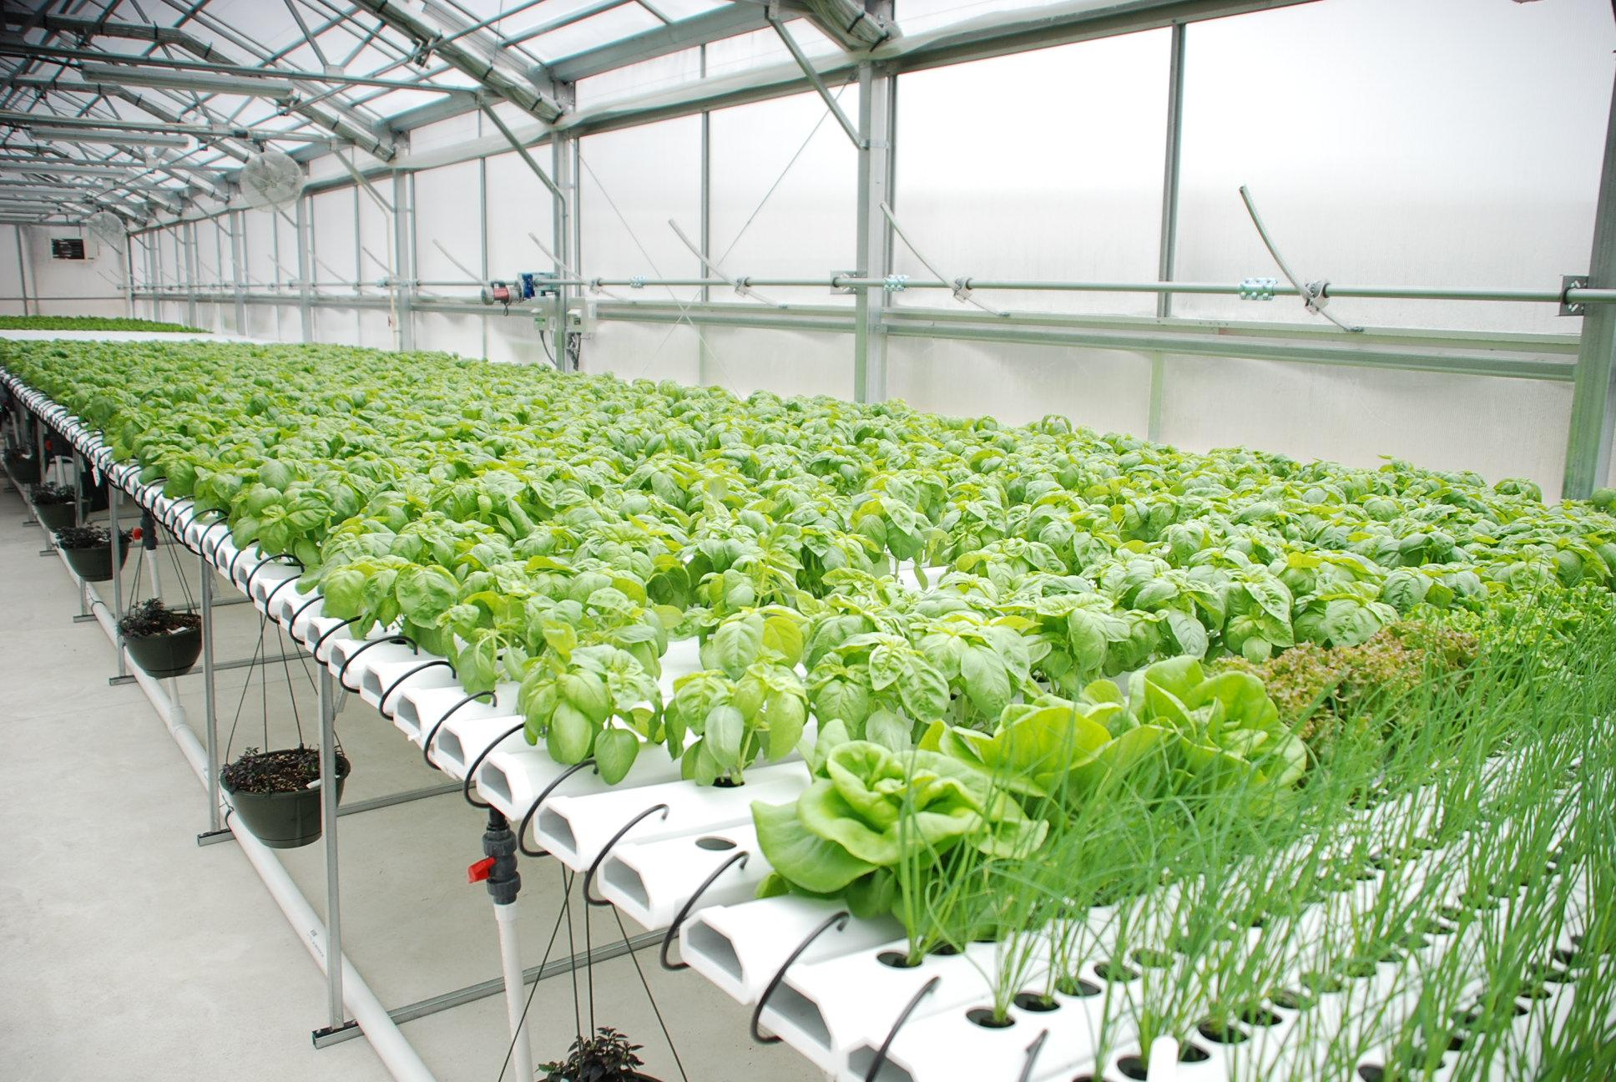
Though hydroponic technology is by no means new. The earliest forms of related technologies can be traced back to the Hanging Gardens of Babylon and the Floating Gardens of China. More modern systems date back about 100 years to an experiment by a professor at the University of California-Berkeley.³ The aquaponics industry has been rapidly expanding and refining its method ever since. Shortly after this experiment, companies began integrating the technology and distributing hydroponically grown produce. The technology has already gained global importance in certain niches of food supply chains.
The sector is expected to grow 22.52% annually over the next 5 years. By FY25, the global valuation of the industry is projected to reach USD 3.66 billion.⁵
Right: An example of a commercial hydroponic system.⁴
As we can see, the next stride of agriculture is well underway. If we look to promote future sustainability and prosperity, we must consider the ethical implications of our emerging technologies. This essay will explore an ethical dilemma regarding hydroponic agriculture.

The attitude of humankind’s separation from nature, resulting from the work of highly influential Enlightenment thinkers, has proliferated into global mismanagement of natural resources and an irresponsible lack of ecological stewardship. This attitude fostered the Industrial Revolution and subsequent human innovations in technology and agriculture that continues to result in anthropocentric climate change. A changing climate threatens our existing food supply chain as water becomes more scarce, growing seasons shift, and growing conditions become harsher. Considering this, hydroponic technology and other CEAs will be essential in the coming years to meet the needs of growing human populations facing climate change. Due to the nature of CEA, which allows for a complete separation between the site of growth and the traditional cultivation environment as well as grants the cultivator full control over the growth climate and nutrient levels, CEA may perpetuate the human attitude that has lead to anthropocentric climate change and the necessity of CEA in sustaining humanity. In short, CEA and hydroponics seems opportune to further solidify the separation between humankind and nature that has caused the necessity of this technology in the first place.
The philosopher Alexander Blum argues that the Cartesian dualism of Rene Descartes fostered the conception of the human being as outside of nature in his essay, How the Enlightenment Separated Humanity from Nature. Francis Bacon equated the scientist to a torturer, compelling nature to reveal the secrets it has been concealing. Further, he points to cases made by another philosopher John Dewey, “The savage is merely habituated; the civilized man has habits which transform the environment.”⁵ We see these attitudes in reflection upon the past centuries of human civilization and expansion.
As human societies sprawled to the west, they brought with them an entitlement to the resources of nature and sought to conquer and possess them. In the fashion of Dewey’s philosophy, humans that could transform an environment to meet their needs were, in fact, more human than those who merely lived within an ecosystem. As we have transformed environments to serve our exponential consumption and necessitated a system of industry and transportation that consequently has climate scientists shaking in their boots, these enlightenment attitudes show their colors still today. Furthermore, as impending climate crises present a shortening timeline, these attitudes globally outcompete unpopular efforts towards sustainability.
In respect to agriculture, if the farmer saw themself as an aspect of the land that they farm, they might think twice before stripping the land of precious nutrients and supplementing all future needs with synthetic applications. In broader terms, humans might reconsider their use of crude oil, plastic, and coal if we considered the well-being of an ecosystem and ourselves to be synonymous. Though this is not the case.
The implications of dualistic and ‘civilized vs. savage’ thought are clearly demonstrated in the current climate crisis and state of human settlements. We have moved progressively farther from regional sustainability, necessitating the transformation of our surrounding environment and transportation of foodstuffs and water. Emblematically, citizens of Los Angeles receive their water from the Colorado River, their bananas from Guatemala, and their tea from east Asia. Alas, we have already dealt our cards.
Hydroponic cultivation of produce presents a great benefit to the continued success of the human project, reducing our consumption of fresh water and significantly reducing transportation needs within the foodstuff supply chain. Quite possibly an essential technology to compensate for the consequences of post-Enlightenment attitudes towards nature. Additionally, hydroponics can be more efficient and less costly if performed correctly. Though I will demonstrate that the technology is an implication of the same attitude that has fostered the climate crisis and commanded the need for hydroponics.
Within the hydroponic growing situation, the farmer establishes a system within a building or facility. This has already separated the act of cultivation from the land and ecosystem that has allowed for the evolution of the cultivated plants. Their facility must be frequently sterilized, to prevent the infringement of unwanted bacterial or fungal agents -- giving the cultivar not only agency but the legal duty to separate their crops from the surrounding natural world. Hydroponic systems are most often built from metal and vinyl or other plastic and the farmer uses a synthetic substrate to seed the desired plant and commence the growth cycle, which evades the traditional need for soil. Artificially extracted nitrates, phosphates, magnesium, calcium, and other micronutrients are precisely fed to the plants on a set schedule and the pH of the nutrient solution is similarly regulated using artificially extracted acids and bases. The plants are sometimes subjected to natural light if raised in a greenhouse, though are often grown using exclusively artificial light. Photosynthesis becomes a process that the farmer commands and provides for, rather than the sun. Under these conditions, the farmer additionally shields the plants from traditional pests like insects, molds/rusts, and other animals.
Within controlled environment agriculture, such momentous effort is exerted to keep the ‘rest’ of nature separate from the human enterprise of cultivation. Emulating the Cartesian dualist attitude towards nature, the cultivar in a sterile, artificially lit room is not only able to see themselves as separate from nature, but further yet, see their agricultural practices as being separate from nature. They have carefully extracted the secrets of natural growth in order to make use of them away from the natural order that birthed them. The stark contrast between traditional and hydroponic cultivation seems to communicate that the civilized human is capable of transforming nature so completely that they need not include nature in their continued survival.
“I was raised in a rural community in Wisconsin, surrounded by dairies, expansive cash crop fields, vegetable farms, and orchards; my house, adjacent to a field rotating corn, alfalfa, and soy. I first encountered CEA when I was in high school. One of my classmates in a biology class had taken an early interest in the technology and decided to build a system in the school. It became my responsibility to take care of this system once my friend had graduated and I quickly became fascinated with the ease and curious nature of growing plants away from the sun and the rain. I failed to think critically about this technology for a long while, appreciating only the lovely sight of lettuces, flowers, and jalepeños growing in the Wisconsin winter, but it eventually dawned on me while weeding in my garden. As my bare feet exchanged heat with the cool, dewy soil one morning, I realized the essential importance of traditional cultivation. If I remove my biological needs from the land beneath me, I am not reminded of my dependence on her. The cyclical wisdom of ‘from dust to dust’ is corrupted if I take my needs elsewhere.” -APS
The previous dilemma may very well be critiqued by citing some ways in which hydroponic technology can be more sustainable than soil cultivation. For example, hydroponics uses up to 70% less water per pound of produce, avoids the use the pesticides and fungicides by growing within a sterile environment, avoids weeds and their resulting inefficiency and additional labor, and allows for larger quantities of product to be grown more quickly with less overall use of resources. Furthermore, one might cite the benefits of reduced transportation externalities.
I will not deny that all of these reasons are important evidence to support how hydroponic technology will be essential to sufficiently feeding a growing human population as we blunder into the future. Allowing peoples in regions with failing or unsustainable water supplies more food for the time being and preventing immediate mass migrations or starvation of at-risk populations. Though I assert this with skepticism.
If we go forth maintaining and deepening the attitude that we are separate from nature, what I argue hydroponic technology will contribute heavily to, history will repeat itself. Marginal improvements in sustainability are wins for humankind’s ecological stewardship, though if they are not accompanied by a shift in attitude, I fear we are only pushing off our inevitable demise.

References
- National Geographic (2020). Agricultural Communities. National Geographic. https://www.nationalgeographic.org/topics/resource-library-agricultural-communities/?q=&page=1&per_page=25. Accessed 29 Mar. 2021.
- Richardson Jim (2020). The Future of Food: Faces of Farming. National Geographic. https://www.nationalgeographic.com/foodfeatures/feeding-9-billion/. Accessed 29 Mar. 2021.
- Espiritu, Kevin (2019). History of Hydroponic: When Was Hydroponics Invented? Epic Gardening. https://www.epicgardening.com/history-of-hydroponics/. Accessed 29 Mar. 2021.
- Rimol (2017). 5 Reasons Hydroponic Growing is More Profitable Than Soil Growing. Rimol Greenhouse Systems. https://www.rimolgreenhouses.com/blog/5-reasons-hydroponic-growing-more-profitable-soil-growing Accessed 31 Mar. 2021.
- Blum, Alexander (2018). How the Enlightenment Separated Humanity From Nature. ARC.https://arcdigital.media/how-the-enlightenment-separated-humanity-from-nature-c008881a61b0 Accessed 31 Mar. 2021.

